Week 5

Case—Brunswick Motors

Analytics Exercise: An MRP Explosion — Brunswick Motors
Recently, Phil Harris, the production control manager at Brunswick, read an article on time-phased requirements planning. He was curious about how this technique might work in scheduling Brunswick's engine assembly operations and decided to prepare an example to illustrate the use of time-phased requirements planning.
Phil's first step was to prepare a master schedule for one of the engine types produced by Brunswick: the Model 1000 engine. This schedule indicates the number of units of the Model 1000 engine to be assembled each week during the last 12 weeks and is shown on the next page. Next, Phil decided to simplify his requirements planning example by considering 300301only two of the many components that are needed to complete the assembly of the Model 1000 engine. These two components, the gear box and the input shaft, are shown in the product structure diagram shown below. Phil noted that the gear box is assembled by the Subassembly Department and subsequently is sent to the main engine assembly line. The input shaft is one of several component parts manufactured by Brunswick that are needed to produce a gear box subassembly. Thus, levels 0, 1, and 2 are included in the product structure diagram to indicate the three manufacturing stages that are involved in producing an engine: the Engine Assembly Department, the Subassembly Department, and the Machine Shop.
The manufacturing lead times required to produce the gear box and input shaft components are also indicated in the product structure diagram. Note that two weeks are required to produce a batch of gear boxes and that all the gear boxes must be delivered to the assembly line parts stockroom before Monday morning of the week in which they are to be used. Likewise, it takes three weeks to produce a lot of input shafts, and all the shafts that are needed for the production of gear boxes in a given week must be delivered to the Subassembly Department stockroom before Monday morning of that week.
In preparing the MRP example Phil planned to use the worksheets shown on the next page and to make the following assumptions:
- 1Seventeen gear boxes are on hand at the beginning of Week 1, and five gear boxes are currently on order to be delivered at the start of Week 2.
- 2Forty input shafts are on hand at the start of Week 1, and 22 are scheduled for delivery at the beginning of Week 2.

Compose an APA-formatted Word document by answering the questions below, no more than three pages in length; please answer each of the questions from the presented case study of your choice.

- Assume that Phil wants to minimize his inventory requirements. Assume that each order will be only for what is required for a single period. Using the forms in the case, calculate the net requirements and planned order releases for the gearboxes and input shafts. Assume that the lot sizing is done using a lot for lot.
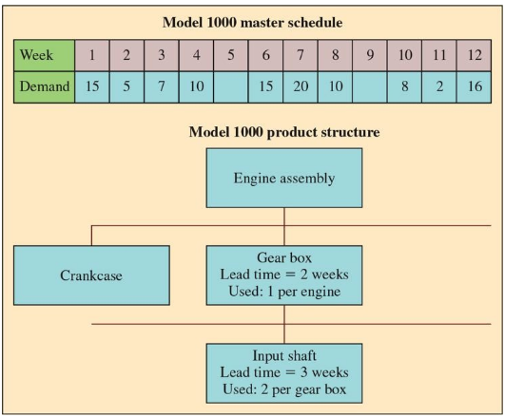

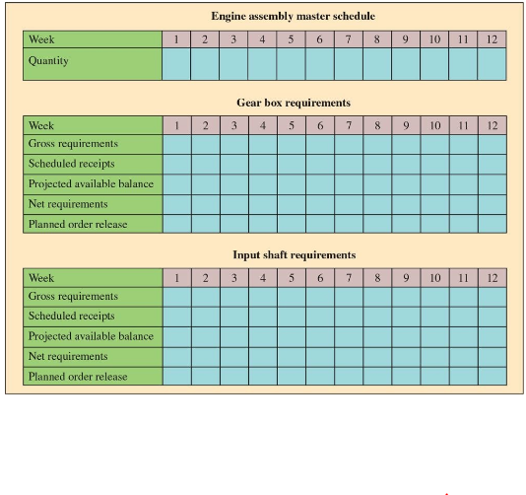
- Calculate a schedule using lease-total-cost lot sizing. What are the savings with this new schedule?

